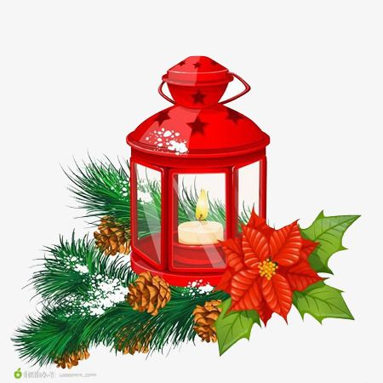
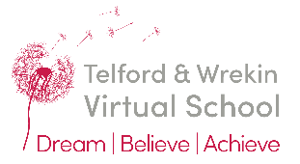

Welcome to Festive crafts!

The Virtual School Team would like to invite you to take part in our festive crafts and carol singing event sessions -being held on four Thursday evenings throughout November and December. The final session is a carol concert at Southwater 1

Where and When?
The venue for The Festive crafts events is going be
House 1, Queensway, Hadley, Telford TF1 7UL.
The events will take place on the 18th, 25th of November and the 2nd of December and will begin at 4pm until 5:30
The Concert will be on the 9th of December at Southwater 1 from 4:45 until 6pm.

What you can expect from the events?
The events will consist of a variety of festive crafts, making lanterns, practising and performing a carol concert, and so much more!

To book a place please contact
Sharron Jones Education Officer / Events Lead sharron.jones@telford.gov.uk by Friday the 5th of November

